The Food Trucks are coming…to Libertytown, MD
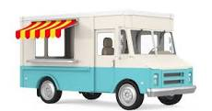
Starting May 8th,2023
2nd and 4th Monday of the month from 5:00 – 8:00 pm

Libertytown Fire Hall Grounds
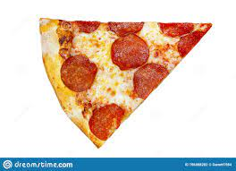

12027 South St. Libertytown, MD
Different Trucks every other Monday including BBQ, Pizza, Mexican, Grilled Cheese, Desserts and more….Drinks for sale by the Libertytown Vol. Fire ept. Aux.
For more info call 301-401-2824
Great food….. Plenty of parking,
picnic table seating, drinks.
Also to-go options available.
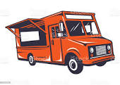

Benefit: Libertytown Vol. Fire Dept. Aux

